Merge Board

Merge Board has current controlled high voltage ideal diode controllers to get a 200A output from two 100A batteries in parallel at 14.8V. To turn off the motors for safety, the 140A output for motors go through a kill switch which is implemented on the merge board. The merge board will also contain a microcontroller for current sensing. The PCB of this subsystem is as follows:

* Current merge circuit:
  + 2 Wire-to-Board connectors to connect two 14.8V, 100A Lithium Polymer batteries. [8 AWG, Mini-Fit Sr.™ Power Wire-to-Board Connectors (Molex)]
  + 2 LTC4357 Positive High Voltage Diode Controllers
  + Arduino Micro development board for current sensing
  + 5V switching regulator to power the Arduino Micro
  + AD8217 Zero-Drift Current Shunt Monitors to find current through sense resistors
  + Infineon OptiMOSTM Power-MOSFETs for the Kill Switch to shut off motors when needed.

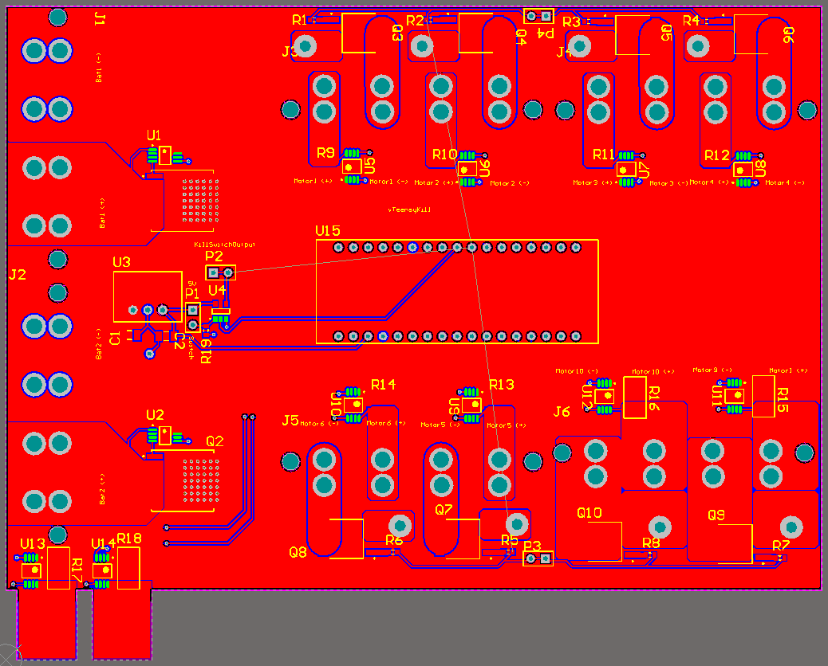

Figure 1.1 PCB layout for the merge circuit.

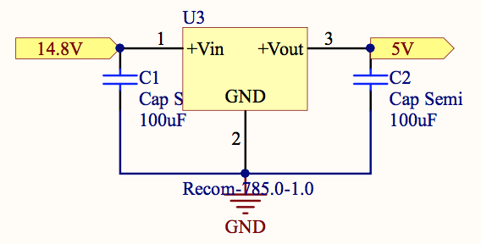

Figure 1.2 Schematic of 5V switching regulator to power the Arduino Micro.

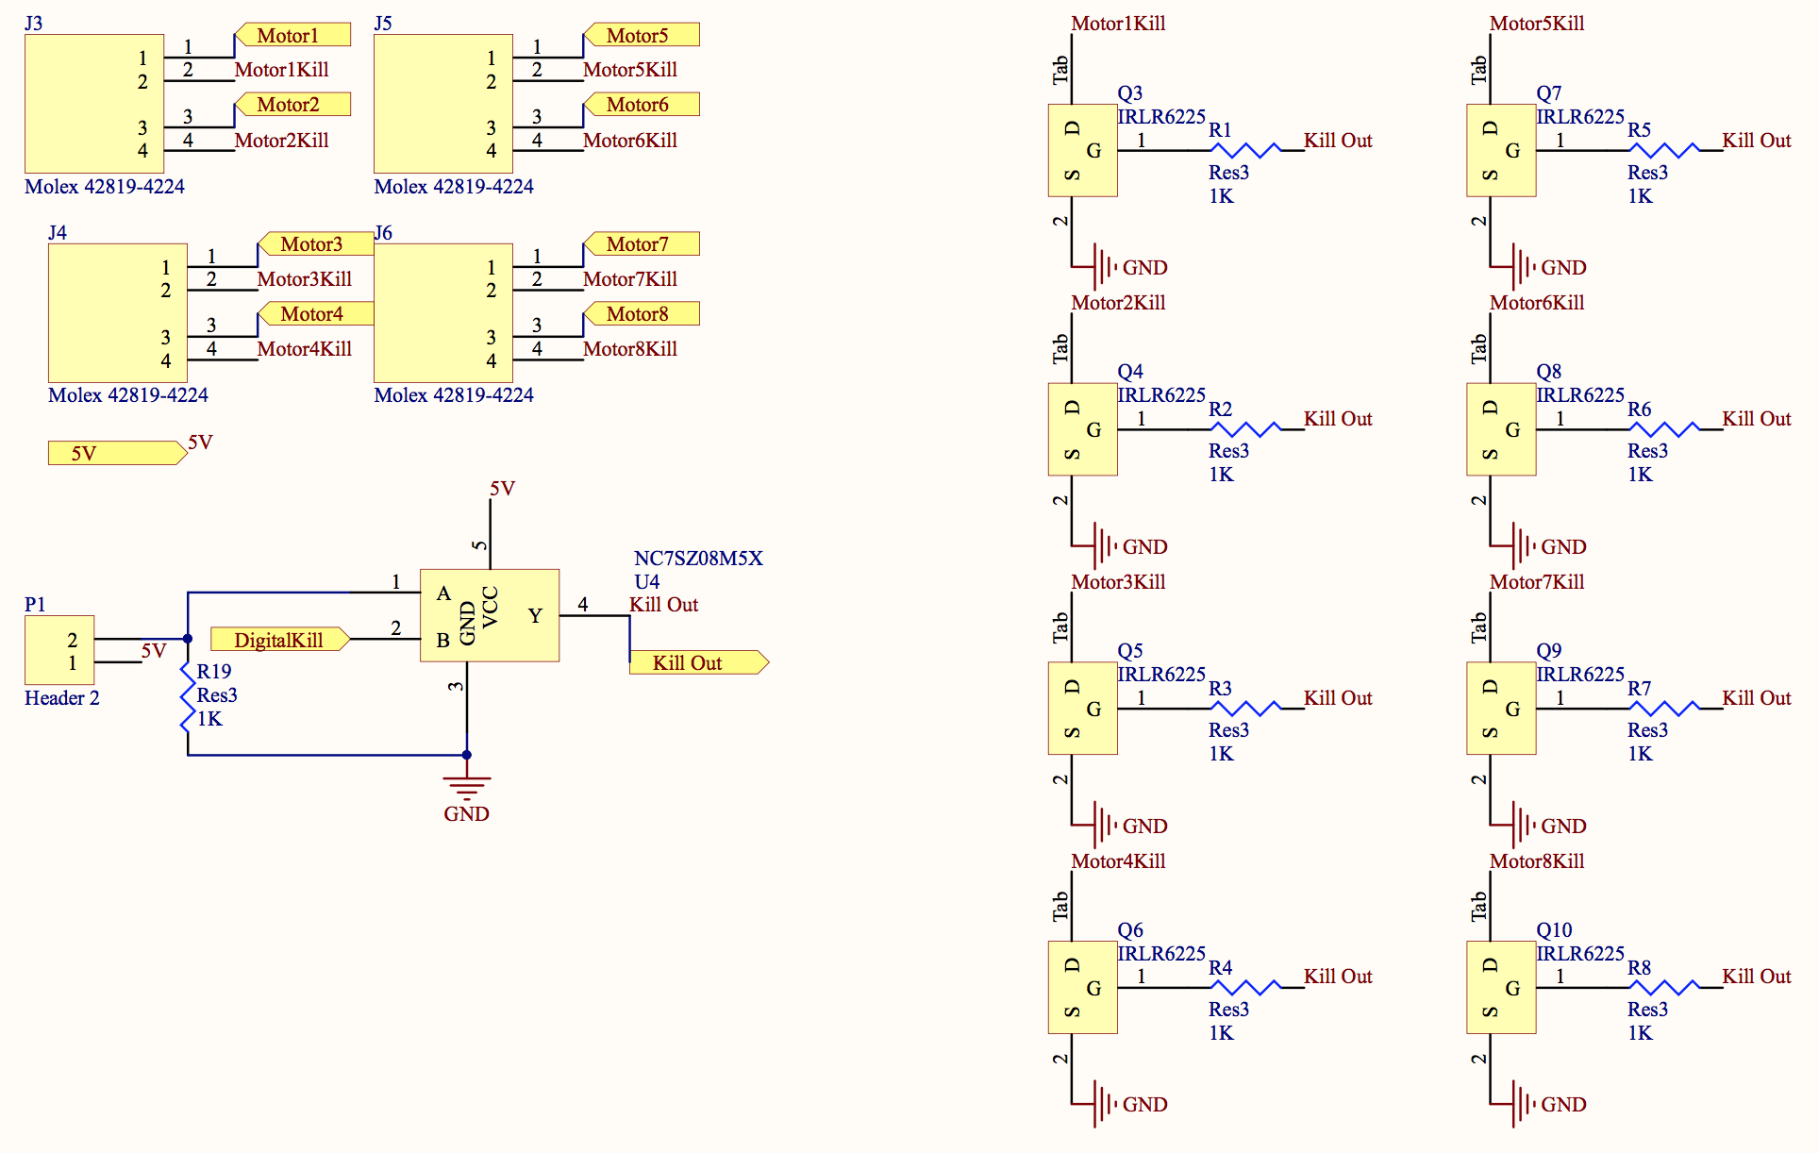

Figure 1.3 Schematic of the Kill Switch to shut off motors

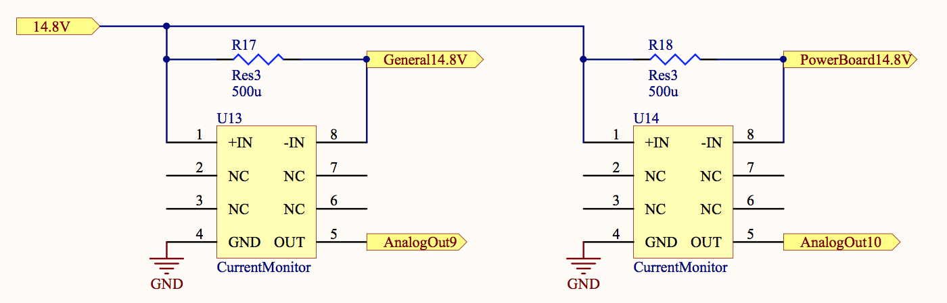

Figure 1.4 Schematic of current shunt monitors

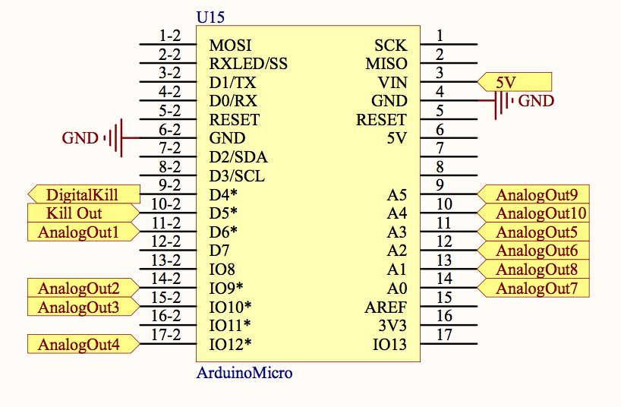

Figure 1.5 Schematic of the Arduino Micro

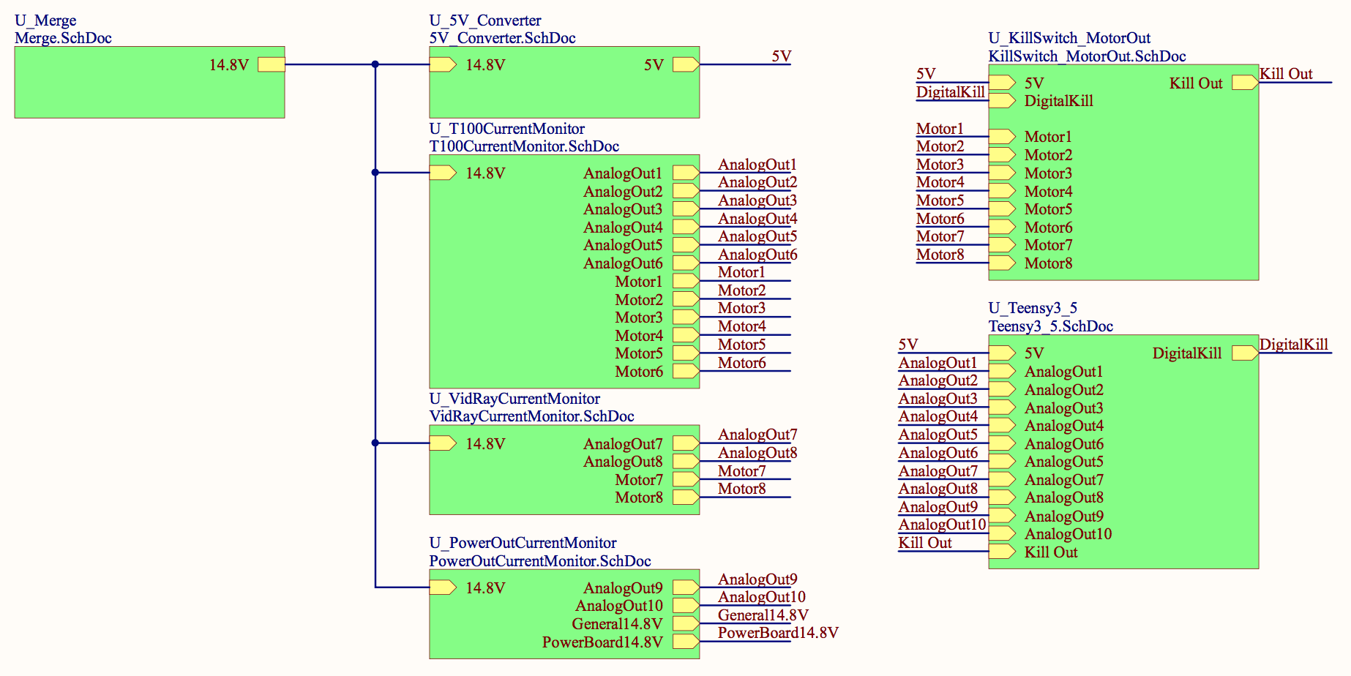

Figure 1.6 Schematic of entire merge circuit

## 1.1 Proof of Concept Test Results

|  |  |  |
| --- | --- | --- |
| **Test** | **Success/Fail** | **Comments/Mitigation plans** |
| Current Merge Circuit | Success | We were able to sense which battery has the higher voltage and only draw current from that battery till the voltage of that battery became equal to the other battery voltage. This makes sure that both batteries discharge at the same rate. |

## 1.2 Integration Test Results

|  |  |  |
| --- | --- | --- |
| **Test** | **Success/Fail** | **Comments/Mitigation plans** |
| Current Merge Circuit | Fail | While the merge section of the current merge board performed correctly, the Teensy 3.5 microcontroller, which controlled the kill switch, failed during normal operations. We believed the cause of the failure to be the Teensy’s lack of voltage regulation, which caused a short between the power and ground rails on the microcontroller. As a result we were unable to pass tests revolving around current monitoring and the kill switch. |

## 1.3 Acceptance Test Results

|  |  |  |
| --- | --- | --- |
| **Test** | **Success/Fail** | **Comments/Mitigation plans** |
| Current Merge Circuit | Success | There were no direct tests related to the merge board, however, we did prove that it could provide the necessary power through the backplane to the power board for us to run the RoboSub final hardware. |

## 2. Theory of Operation

The Merge board works by using high voltage diode controllers to effectively perform a logical ‘OR’ operation on the outputs of two batteries (14.8V 10 Ah LiPo’s), using diodes from LTC. This allows the power system to a) draw current from both batteries simultaneously when at equal charge and b) draw current from the more-charged (higher voltage) battery when the two are not equal, while avoiding the possibility of back-charging, where current flows from the battery with higher voltage into the other. This allows us to draw up to a theoretical 200 A current, well above the 140 A that we anticipate will be the maximum instantaneous current draw at peak power consumption for the system. This is also much more than the 100 A current limit of each individual battery.

## 3. Design Notes

Future iterations of the merge board should update the footprint for the Arduino Micro, as it currently is designed as a shield rather than an attachement.